**2017-06-12:**

Jira on DELL desktop is version 7.2.4, license is expired.

Next steps:

1. Uninstall Jira from DELL desktop.

2. Get evaluation license for version 7.3 and consider evaluation license for “Portfolio for Jira”.

3. Install Jira on HP-2012R2

**2017-06-14:**

Installing Jira 7.3.7 on HP-2012R2

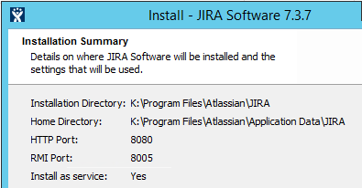

Server ID: BVR1-0XW9-7F2C-K6HX

Administrator account: u: Jiraadmin p: Jiraadmin1

<http://localhost:8080/secure/WelcomeToJIRA.jspa>.

**2017-06-15:**

└───Issue structures

├───Jira

│ └───Epic

│ ├───Bug

│ │ └───Sub-task

│ ├───Story

│ │ └───Sub-task

│ └───Task

│ └───Sub-task

└───VSTS

└───Epic

└───Feature

├───Bug

│ └───Task

└───PBI (Pending Backlog Item)

└───Task

**2017-06-13:**

Jira on HP-2012R2 upgraded to version 7.4

New trial license installed, valid until 11 August 2017.

GitHub

<https://github.com/kristurek1956>

u: KrisTurek1956

p: Krzysiek12

From Visual Studio:

<https://kristurek.visualstudio.com/_git/StocksAI>

**2017-08-13:**

VSTS: <https://kristurek.visualstudio.com/StocksAI/_home>